
cloud computing
[Document subtitle]

10-feb-2026
laiba mudassar
Information communication Technology

Contents
1. Introduction 1
2. Types of Cloud Computing 2
3. Advantages & Disadvantages 2
4. Uses 2
5. Table: Cloud Service Providers 3
6.FIGURE 3
7. Conclusion 3

1. Introduction
Cloud computing is a technology that allows users to store and access data over the internet instead of a computer’s hard drive. It makes data available anytime and anywhere.

2. Types of Cloud Computing
- Public Cloud: Shared services (Google Drive).
- Private Cloud: Used by one organization.
- Hybrid Cloud: Combination of both.

3. Advantages & Disadvantages
Advantages
- Low cost
- Easy access
- Backup & security
Disadvantages
- Internet required
- Privacy risks

4. Uses
- Online storage (Google Drive, Dropbox)
- Email services
- Online classes
- Business data storage

5. Table: Cloud Service Providers

Provider | service example | storage
Google drive | file storage | 15 gb free
drop box | file sharing | 2 gb free
one drive | microsoft storage | 5 gb free

6.FIGURE
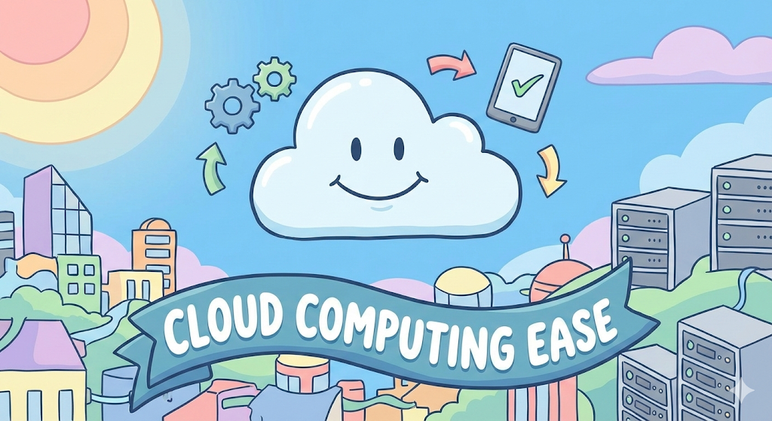
Figure 1 CIOUD COMPUTING

7. Conclusion
Cloud computing makes data storage easy, fast, and accessible. It is widely used in education, business, and daily life.

Bibliography
THOMAS, E. (2009). CLOUD COMPUTING. USA: PRAVIN.

